PROJECT REPORT
COURSE CODE: 24ADI204
COURSE TITLE:DATA SCIENCE AND VISUALIZATION
The Churn Detective
SUBMITTED BY
GOWTHAM S (25BAD027)
HARIHARAN B(25BAD030)
NIZANTH B C (25BAD076)

DEPARTMENT OF ARTIFICIAL INTELLIGENCE AND DATA SCIENCE
KUMARAGURU COLLEGE OF TECHNOLOGY
(Autonomous Institution)
COIMBATORE – 641 049
INTRODUCTION:
The project “The Churn Detective: The Leak in the Bucket” focuses on analyzing customer churn in the telecommunications/subscription service domain. Customer churn refers to the situation where customers discontinue or cancel their subscription to a service.
The project uses customer demographic, service usage, account, and billing information to identify patterns associated with customer churn. Exploratory Data Analysis (EDA) is performed to understand customer behavior and identify relationships between different variables. Principal Component Analysis (PCA) is then applied to reduce the dimensionality of relevant numerical features while retaining the most important information.
The analysis aims to identify the major factors associated with customer cancellation and provide meaningful insights that can help businesses improve customer retention and reduce revenue loss.
Domain:
Telecommunications / Subscription Services
The telecommunications industry provides services such as mobile connections, internet, telephone, and subscription-based digital services to customers.
Customer retention is an important aspect of this domain because acquiring a new customer can require significant marketing and operational costs. When customers leave a service provider, the company loses recurring revenue and may also need to spend additional resources to acquire replacement customers.
Customer churn analysis helps telecom companies understand who is leaving, what characteristics they have, and which service or account-related factors are associated with churn.
In this project, a Telco Customer Churn dataset is used to analyze customer demographics, services, contract details, payment methods, tenure, monthly charges, and other relevant attributes.
Problem Statement
Telecommunication and subscription-based companies face the challenge of losing customers who discontinue their services. If the reasons behind customer churn are not properly identified, companies may lose recurring revenue and valuable customers.
The problem is to analyze customer demographic, service usage, billing, and account-related data to identify patterns associated with customer churn.
Since the dataset can contain several numerical and correlated variables, analyzing all variables simultaneously can make it difficult to identify the underlying patterns. Therefore, PCA is used as a dimensionality-reduction technique to transform relevant numerical variables into a smaller number of principal components while retaining important information.
The project aims to use EDA and PCA to discover meaningful patterns that can help understand customer churn and support customer-retention strategies.

Problem Abstract
Customer churn is a major business challenge for telecommunications and subscription-based service providers because the loss of customers directly affects recurring revenue and business growth. This project, titled “The Churn Detective: The Leak in the Bucket,” analyzes customer data to understand the factors and patterns associated with customer cancellation.
The project begins with data preprocessing and exploratory data analysis to examine customer demographics, tenure, service subscriptions, contract types, payment methods, monthly charges, and other relevant variables. Various visualizations are used to identify distributions, relationships, trends, and differences between customer groups.
To handle multiple numerical variables and identify the underlying structure of the data, Principal Component Analysis (PCA) is applied. PCA transforms correlated variables into a smaller set of principal components that capture the maximum possible variance in the data. The resulting components are analyzed to understand the major dimensions of customer behavior.
The final analysis provides insights into customer characteristics and service-related patterns associated with churn. These insights can help businesses understand potential areas of customer dissatisfaction and develop strategies aimed at improving customer retention and reducing revenue leakage.
OBJECTIVES:
- To understand customer churn behavior using a telecommunications customer dataset.
- To perform data preprocessing by handling missing values, inconsistent data, categorical variables, and numerical features.
- To conduct Exploratory Data Analysis (EDA) to understand customer demographics, services, contracts, billing, and usage patterns.
- To identify relationships between numerical variables using appropriate statistical and visual techniques.
- To compare churned and non-churned customers based on important demographic, service, and account-related characteristics.
- To identify highly correlated numerical variables that may contain overlapping information.
- To apply Principal Component Analysis (PCA) for dimensionality reduction.
- To determine the principal components that explain the major variation in the customer dataset.
- To interpret the important variables contributing to the principal components and understand the underlying customer behavior.
- To generate actionable business insights that can support customer-retention efforts.

Challenges
- Data Cleaning – Handling missing, inconsistent, and incorrect data.
- Categorical Data – Converting categorical variables into numerical form for analysis.
- Feature Scaling – Standardizing numerical features before applying PCA.
- High Dimensionality – Managing a large number of variables and reducing them using PCA.
- Feature Correlation – Identifying relationships and redundancy among variables.
- PCA Interpretation – Understanding the contribution of original variables to each principal component.
- Churn Analysis – Identifying meaningful patterns related to customer cancellation.
WEEK 1 :
TEAM FORMATION AND DATA HUNTING
TEAM NO:
TEAM MEMBERS:
25BAD027-GOWTHAM S
25BAD030-HARIHARAN B
25BAD076-NIZANTH B C
GITHUB LINK:
https://github.com/hariharan0528/24ADI204-DSV_PROJECT_CHURN_DETECTIVE
DATASET:
https://www.kaggle.com/datasets/sameerhussain007/subscription-churn-dataset/data

ABOUT DATASET:
The Telco Customer Churn Dataset contains information about customers of a telecommunications service provider. It includes demographic details, account information, service subscriptions, contract types, payment methods, tenure, monthly charges, and total charges. The dataset also contains a Churn variable indicating whether a customer has left the service or continued as a customer. It is used to analyze customer behavior, identify patterns related to churn, and apply EDA and PCA to find important factors associated with customer cancellation.

TEAM CONTRIBUTION:
TEAM MEMBER | CONTRIBUTION
GOWTHAM S | Set up and maintained the Github repository to enable version control and collaborative development.
HARIHARAN B | Analyzed and interpreted the project problem statement to identify key challenges and objectives.
NIZANTH B C | Exxplored and analyzed the selected dataset on kaggle to understand its structure, features and relevance to the project.

WEEK 2:
KNOW YOUR DATA
OBJECTIVE:
The objective is to gain an initial understanding of the dataset before performing further analysis. This involved loading the dataset into the python environment,examining its structure,identifying data types, and generating a preliminary overview of the data.
USED PACKAGES AND METHODS:
Packages: pandas
METHODS: head(),tail(),info(),describe(),isnull(),sum()
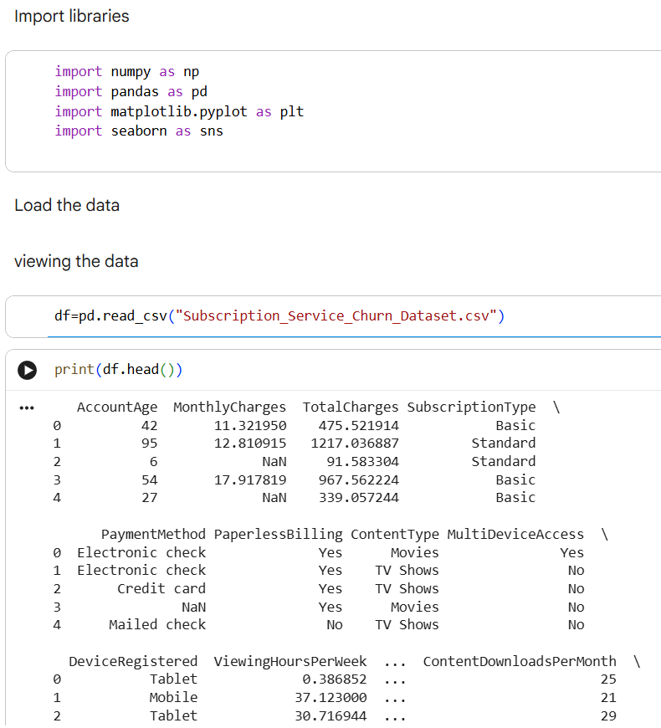
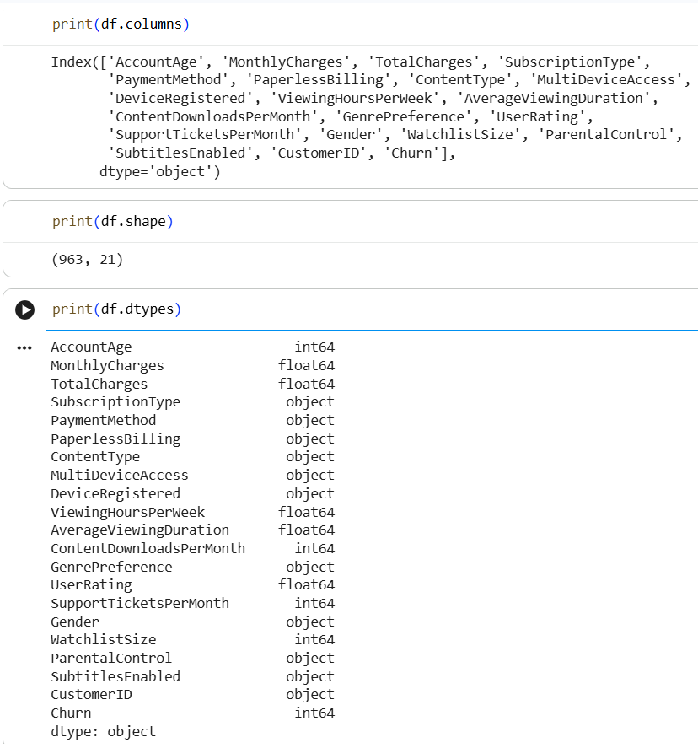
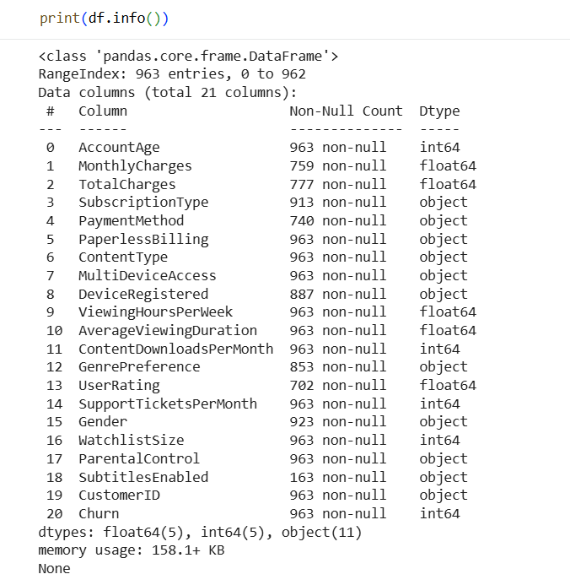

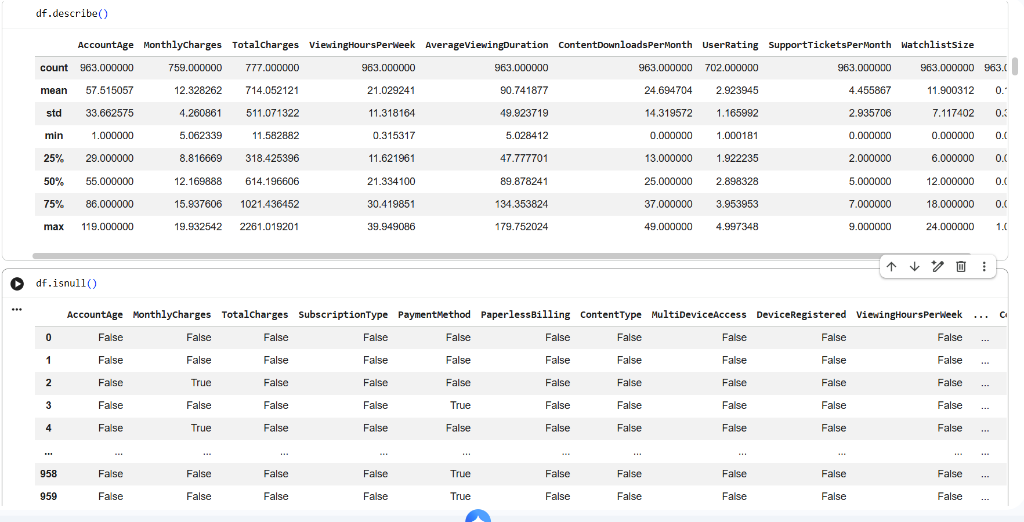
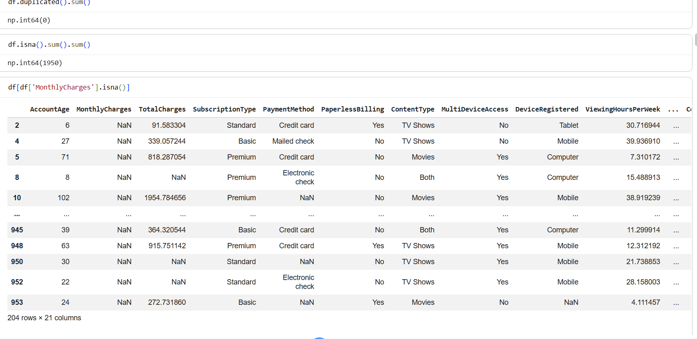
INTERPRETATION:
The Subscription Service Churn Dataset contains customer-level information that helps analyze subscription behavior and customer retention. It includes 963 records and 21 variables, covering customer demographics, account details, subscription plans, payment information, viewing behavior, content preferences, charges, and customer support interactions. Numerical attributes such as account age, monthly charges, total charges, viewing hours, ratings, downloads, and support tickets help measure customer usage and spending patterns. Categorical attributes provide information about customers’ subscription and service preferences. The Churn variable indicates whether a customer has cancelled the service. By analyzing these variables through EDA and PCA, the dataset can be used to identify important patterns and factors associated with customer churn.
TEAM CONTRIBUTION:
TEAM MEMBER | CONTRIBUTION
GOWTHAM S | Prepared the documentation and recorded the weekly progress for the project report.
HARIHARAN B | Analyzed the dataset attributes and interpreted the statistical summary generated from the data.
NIZANTH B C | Verified the data types of the attributes and examined the dataset for missing values

WEEK 3:
THE CLEANING SPRINT
OBJECTIVE:
The objective of the Cleaning Sprint is to identify and handle data-quality issues in the Subscription Service Churn Dataset before performing EDA and PCA. The dataset is checked for missing values, data types, duplicate records, and irrelevant identifiers. Numerical and categorical variables are prepared in appropriate formats so that the cleaned data can be used reliably for visualization, statistical analysis, feature scaling, and PCA.

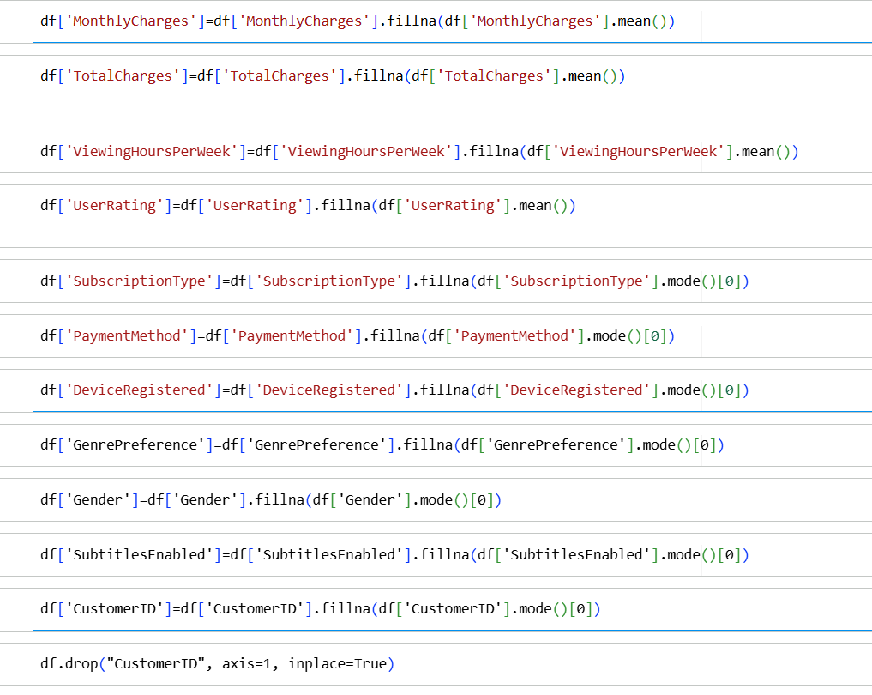

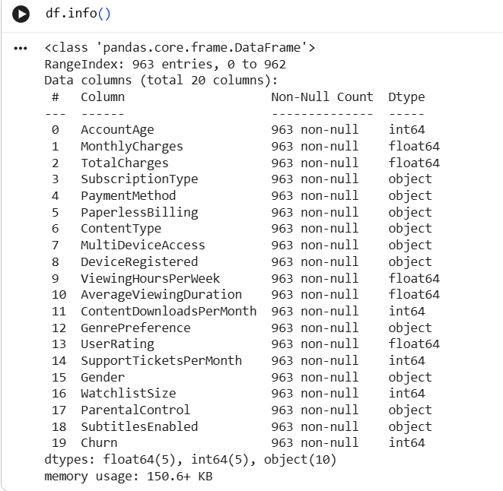

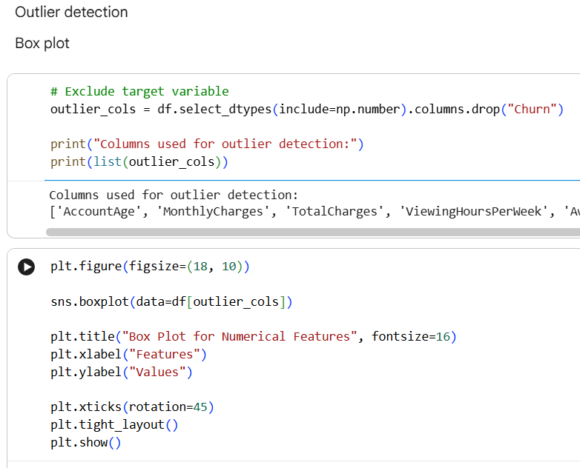

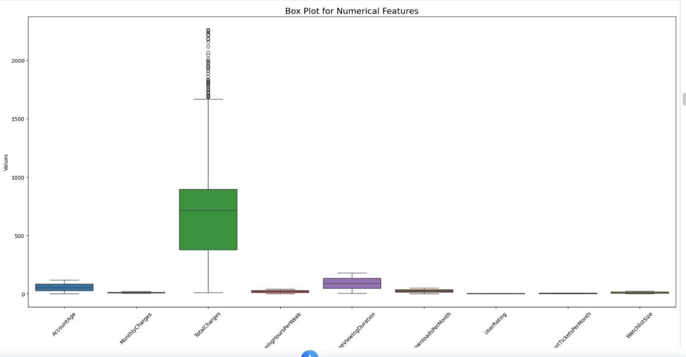

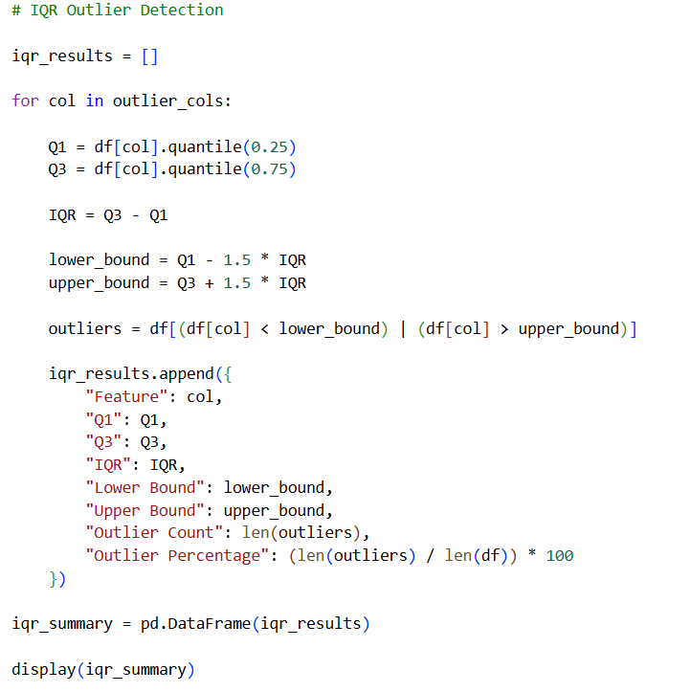

INTERPRETATION:
The dataset contains 963 customer records and 21 variables. There are no duplicate records, indicating that each row represents a unique customer entry. However, several columns contain missing values. SubtitlesEnabled has the highest number of missing values, followed by UserRating, PaymentMethod, MonthlyCharges, TotalCharges, GenrePreference, DeviceRegistered, SubscriptionType, and Gender. The remaining variables do not contain missing values.
The dataset contains both numerical and categorical variables. Numerical features such as AccountAge, MonthlyCharges, TotalCharges, ViewingHoursPerWeek, AverageViewingDuration, ContentDownloadsPerMonth, UserRating, SupportTicketsPerMonth, and WatchlistSize can be used for statistical analysis and PCA after appropriate preprocessing and scaling. Categorical features such as SubscriptionType, PaymentMethod, ContentType, and GenrePreference require suitable encoding when used in numerical analysis.
The CustomerID column is a unique identifier and does not provide meaningful numerical information for PCA, so it can be excluded from the analytical features. The Churn column is the target variable and should be retained for comparing customer characteristics between churned and non-churned customers.
Overall, the cleaning sprint shows that the major data-quality issue in this dataset is missing information rather than duplicate records. Properly handling these missing values and preparing the variables will provide a reliable dataset for the next stages of EDA, feature scaling, and PCA.
TEAM CONTRIBUTION:
TEAM MEMBER | CONTRIBUTION
GOWTHAM S | Generated visualizations and analyzed outliers using boxplots.
HARIHARAN B | Performed statistical outlier detection using the IQR method and interpreted the results.
NIZANTH B C | Reviewed the cleaned dataset and verified the preprocessing results after handling missing values and outliers.

WEEK 4:
EDA DEEP DIVE
OBJECTIVE:
The main objective of the EDA Deep Dive is to explore the cleaned Subscription Service Churn Dataset in detail and understand the underlying patterns in customer behavior. The analysis focuses on examining the distribution of numerical variables, frequency of categorical variables, relationships between important features, and differences between churned and retained customers. Various visualizations such as histograms, box plots, bar charts, scatter plots, and correlation heatmaps are used to identify trends, outliers, correlations, and unusual patterns. The findings from this stage will help identify the variables that have meaningful relationships with customer churn and provide a strong foundation for the subsequent feature scaling and PCA analysis.
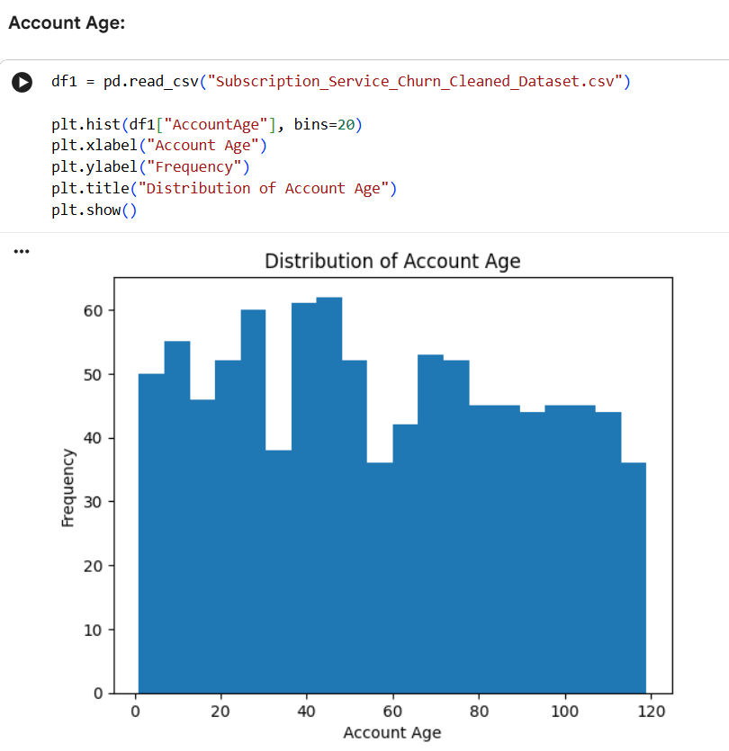

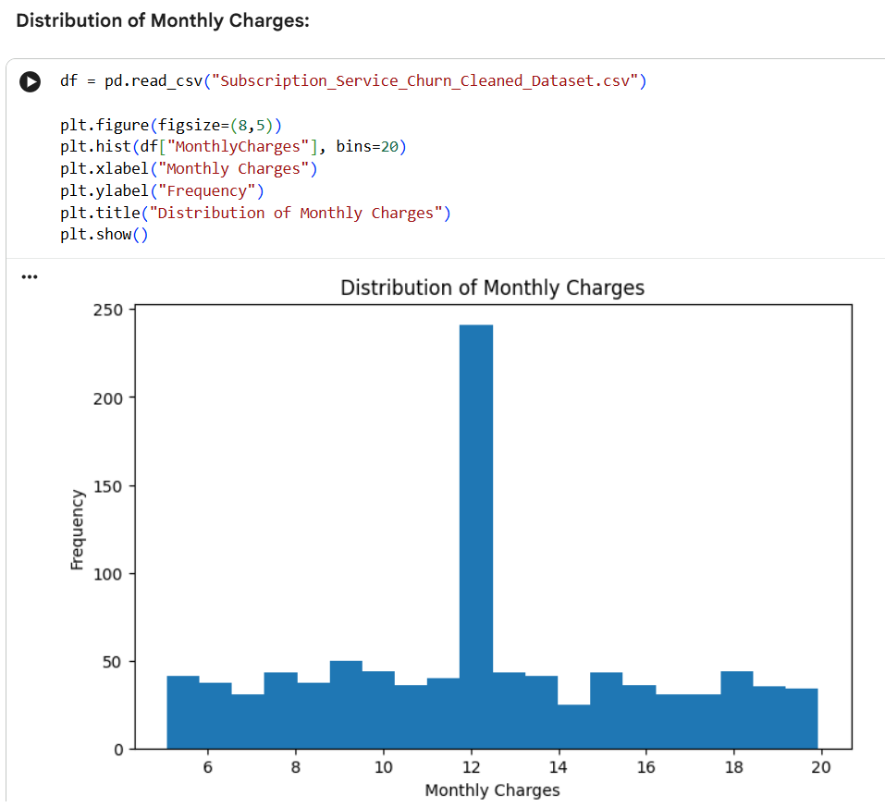

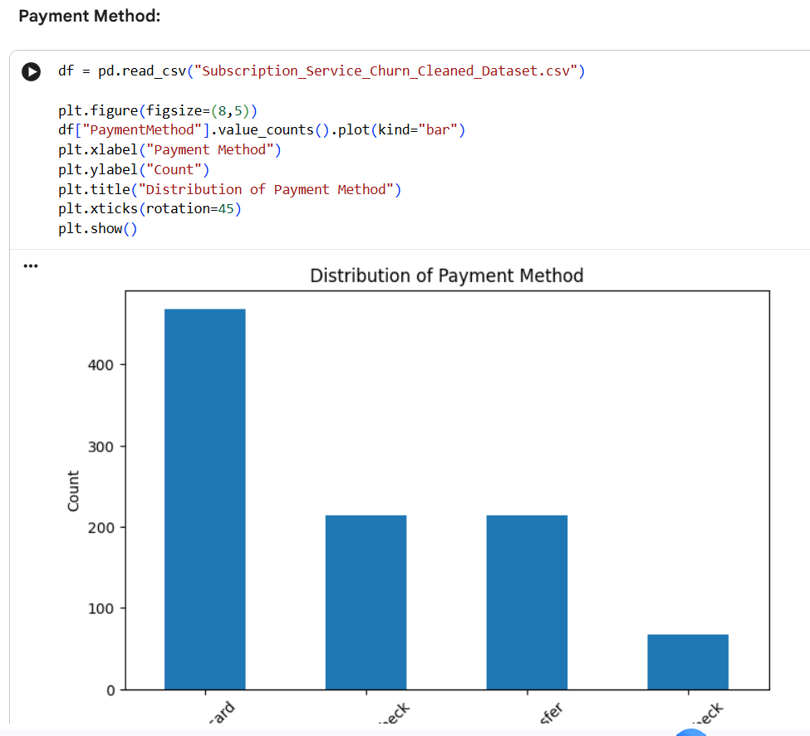

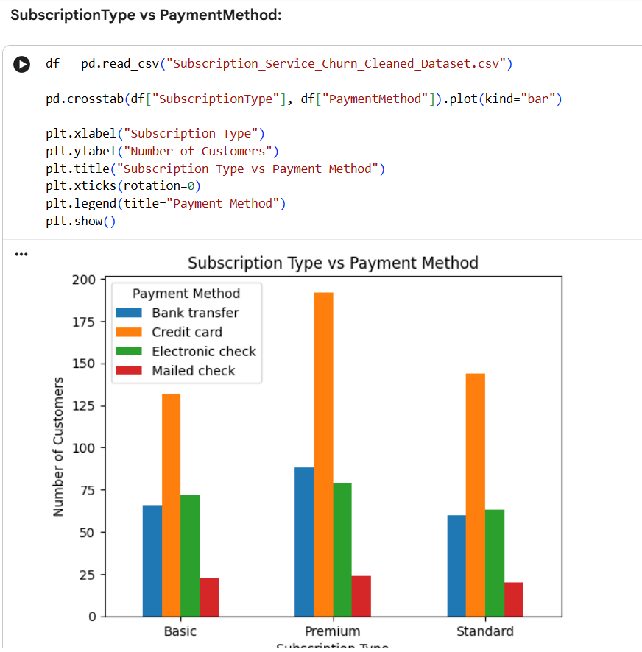

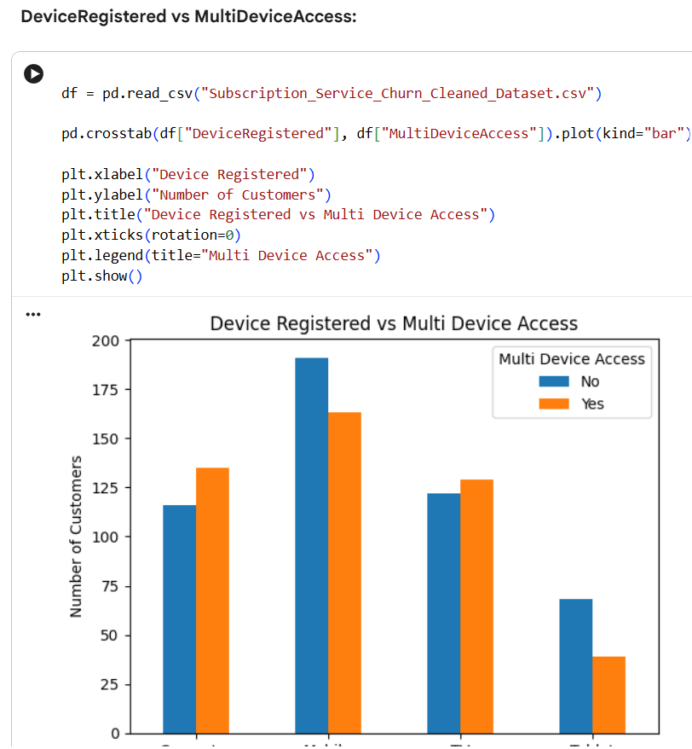

INTERPRETATION:
The EDA Deep Dive provides a detailed picture of how customers use and interact with the subscription service. The distributions of variables such as AccountAge, MonthlyCharges, TotalCharges, ViewingHoursPerWeek, AverageViewingDuration, ContentDownloadsPerMonth, UserRating, SupportTicketsPerMonth, and WatchlistSize help understand the typical customer profile and identify unusual observations or outliers.
The categorical variables, including SubscriptionType, PaymentMethod, ContentType, DeviceRegistered, and GenrePreference, help examine differences in customer preferences and subscription behavior. Bivariate analysis is used to study meaningful relationships between variables, such as AccountAge and TotalCharges, MonthlyCharges and TotalCharges, and ViewingHoursPerWeek and AverageViewingDuration.
A major focus of the EDA is comparing churned and non-churned customers. This helps determine whether customer usage, spending, subscription characteristics, or support interactions show noticeable differences between the two groups. Correlation analysis further helps identify relationships among numerical variables and detect features that may contain similar information.
Overall, the EDA Deep Dive transforms the cleaned raw data into meaningful customer-behavior insights. These insights help determine which variables should receive further attention during feature scaling and PCA, while also providing a clearer understanding of the possible patterns associated with customer churn.

TEAM CONTRIBUTION:
TEAM MEMBER | CONTRIBUTION
GOWTHAM S | Interpreted the values from the attributes and gathered nencessary insights to build univariate and bivariate plots.
HARIHARAN B | Generated univariate analysis and created distribution plots,histograms, to understand churn detective patterns.
NIZANTH B C | Generate bivariate visuaisations such as bar plot,scatter plot,and box plot and analyzed the relationship between transaction amount,fraud,and time
REFERENCES:
https://www.kaggle.com/datasets/sameerhussain007/subscription-churn-dataset/data

WEEK 6 :
FEATURE ENGINEERING. NORMALIZATION, SCALING AND ENCODING CATEGORICAL VARIABLES. FIXING SKEWNESS

OBJECTIVE:
To perform feature engineering by applying normalization and scaling techniques to numerical data, encoding categorical variables into suitable numerical formats, and handling skewness in data distribution to improve data quality and enhance the performance of machine learning models.

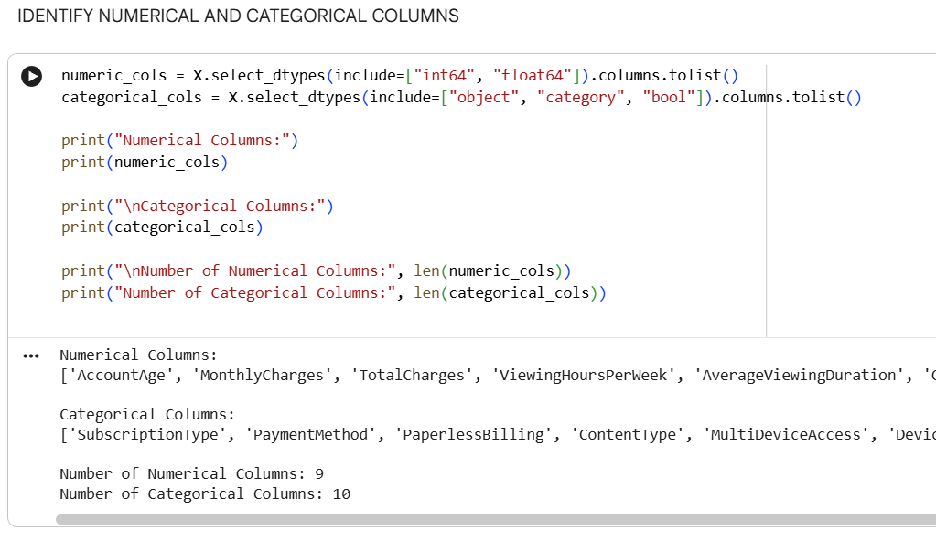

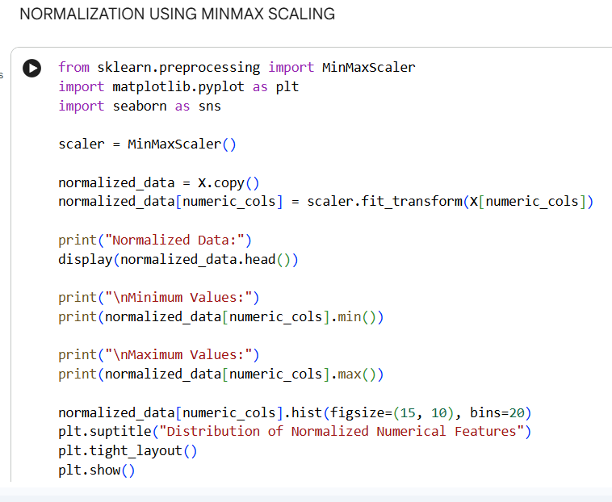
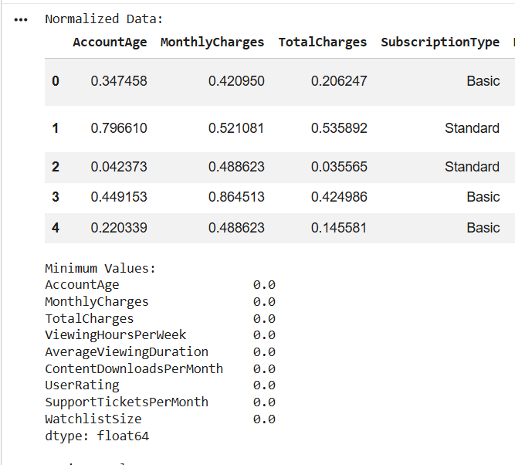

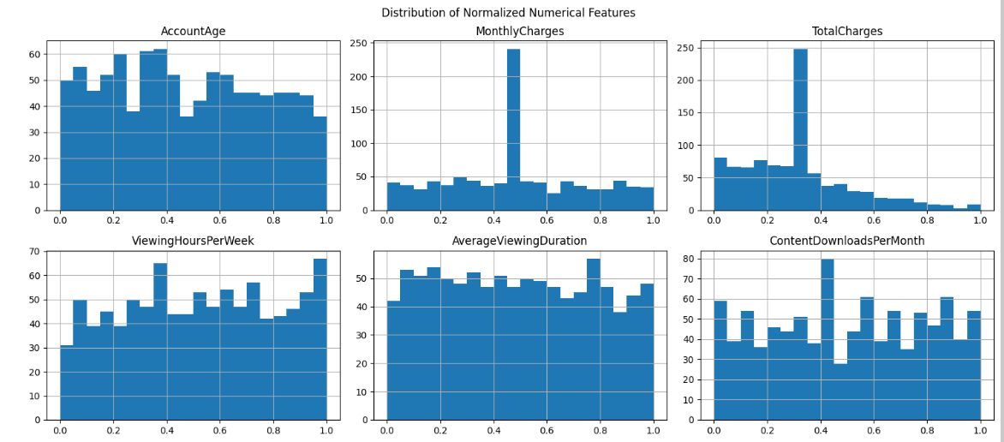

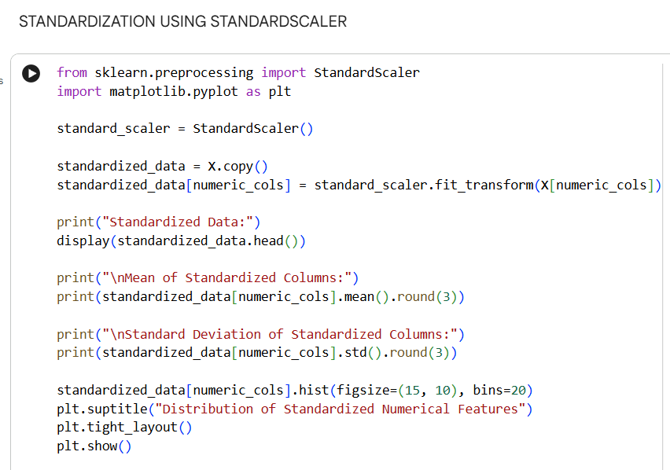

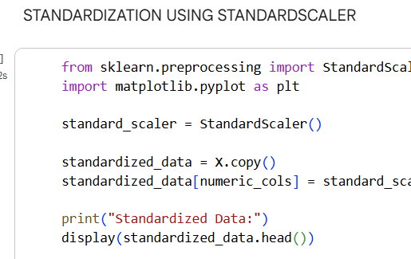

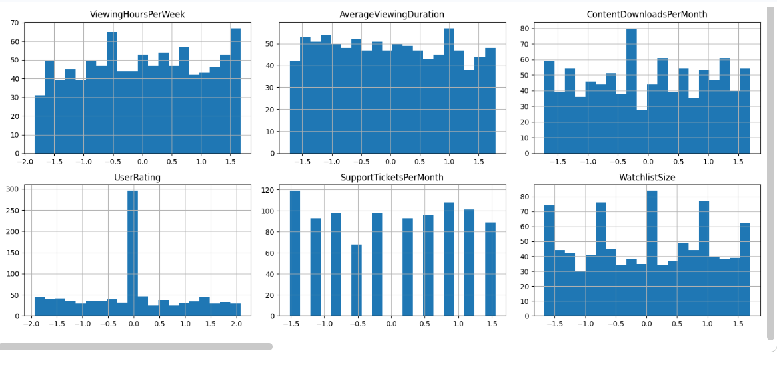

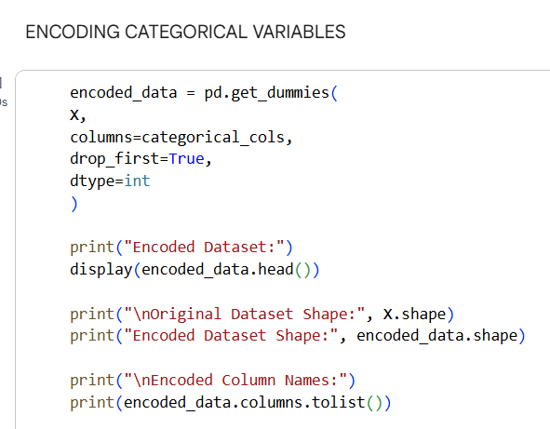
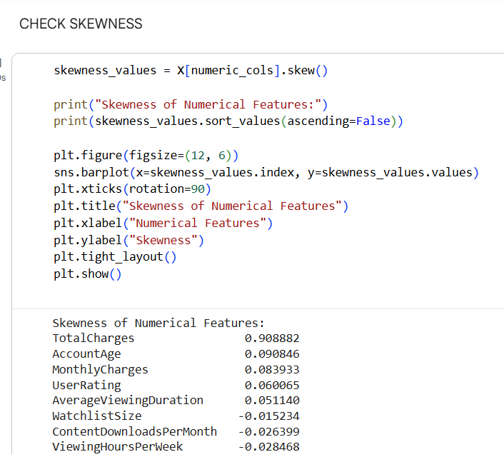

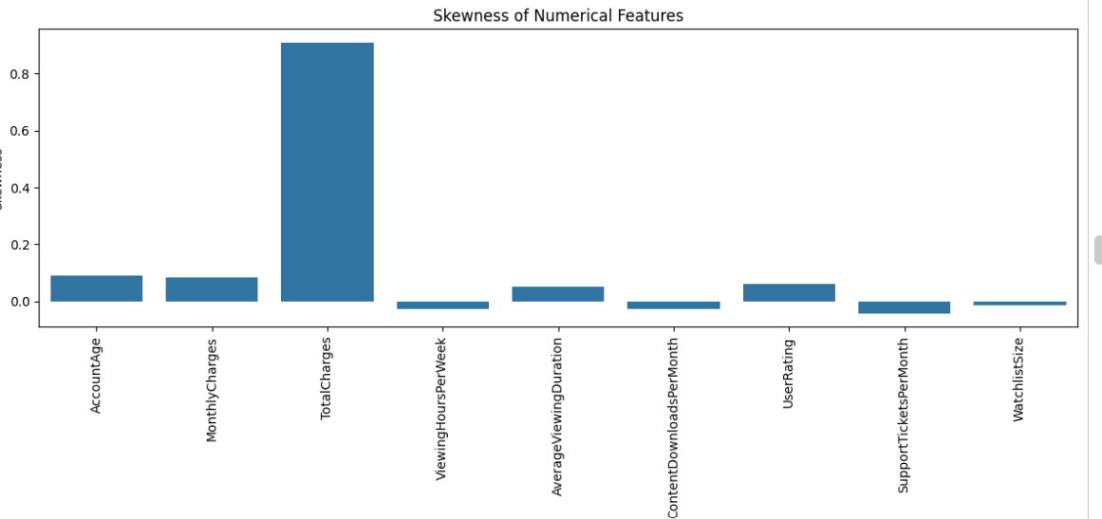

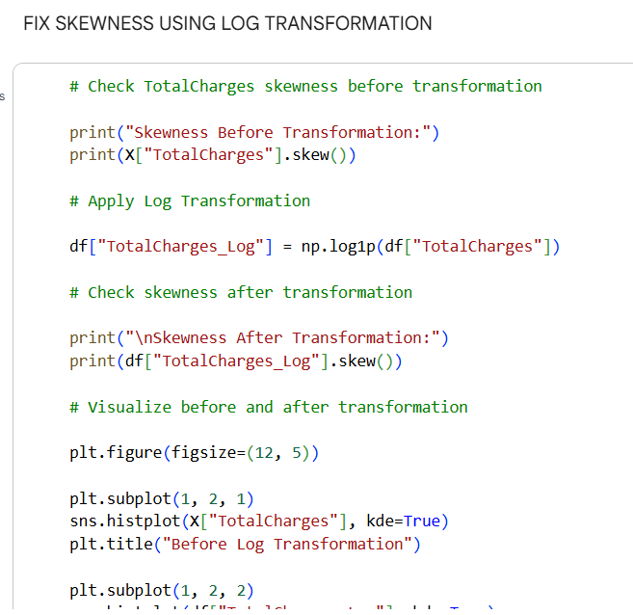

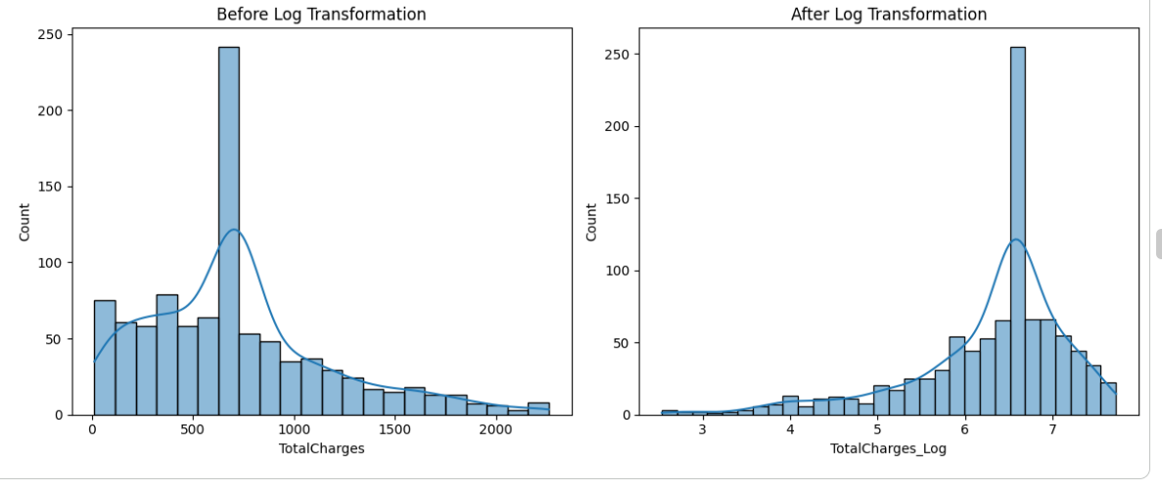

INTERPRETATION:

- Feature engineering was performed to improve data quality by transforming numerical and categorical variables for better model performance.

- Skewness analysis revealed that several numerical features were highly skewed, indicating an uneven distribution of values.

- Log transformation was applied to highly skewed features, which helped in reducing skewness and making the data more normally distributed.

- Categorical variables were encoded using label encoding, converting non-numeric data into machine- readable numerical form.

- Standard scaling was applied to normalize features with mean 0 and standard deviation 1, ensuring that all features contribute equally to the model.

- Min-Max normalization scaled the data into a fixed range (0 to 1), preserving the relative differences between values.

- The histogram after skewness correction shows a more balanced and symmetric distribution, indicating successful transformation.

- The distribution after standard scaling shows values centered around zero, confirming proper standardization.

- The normalized feature distribution demonstrates that all values are bounded within the range of 0 to 1, making it suitable for algorithms sensitive to scale.

- Overall, feature engineering improved the dataset by reducing skewness, standardizing feature scales, and encoding categorical data, making it ready for machine learning model development.

TEAM CONTRIBUTION:
TEAM MEMBERS | CONTRIBUTION
GOWTHAM S | Identified numerical features, analyzed skewness and applied log transformation to reduce data skewness
HARIHARAN B | Performed encoding of categorical variables and generated visualizations to analyze feature distributions after transformation
NIZANTH B C | Applied standard scaling and Min Max Normalization techniques and compared their effects on the dataset

WEEK 7:
DIMENSIONALITY REDUCTION. IMPLEMENTING FEATURE SELECTION AND PCA. VISUALIZING VARIANCE.

OBJECTIVE:

To perform dimensionality reduction by applying feature selection techniques and principal components Analysis (PCA) in order to reduce the number of features, eliminate redundancy, and retain maximum variance in the dataset, thereby improving model efficiency and visualization of data patterns

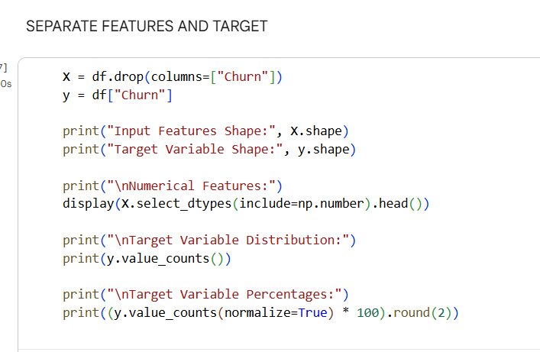

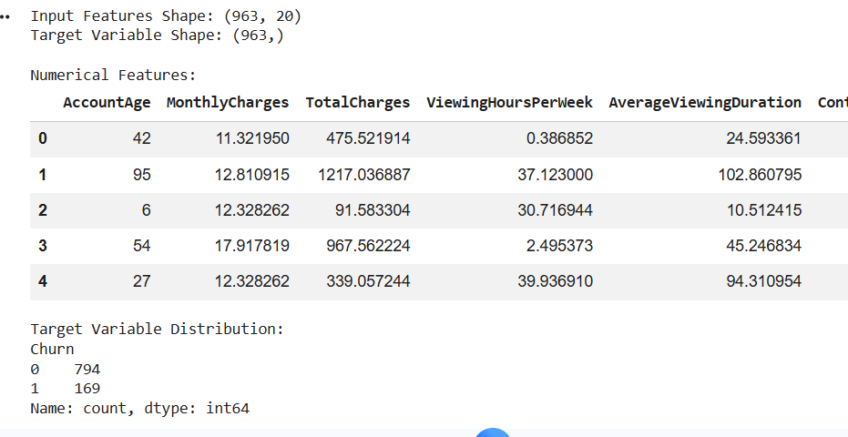

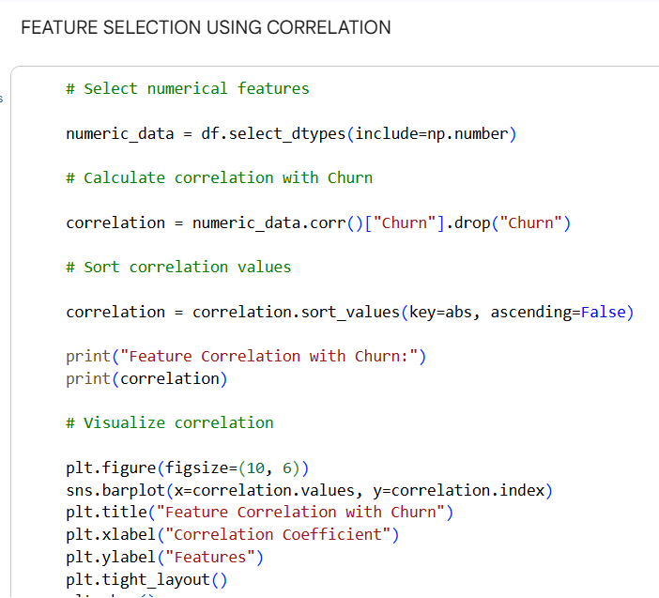

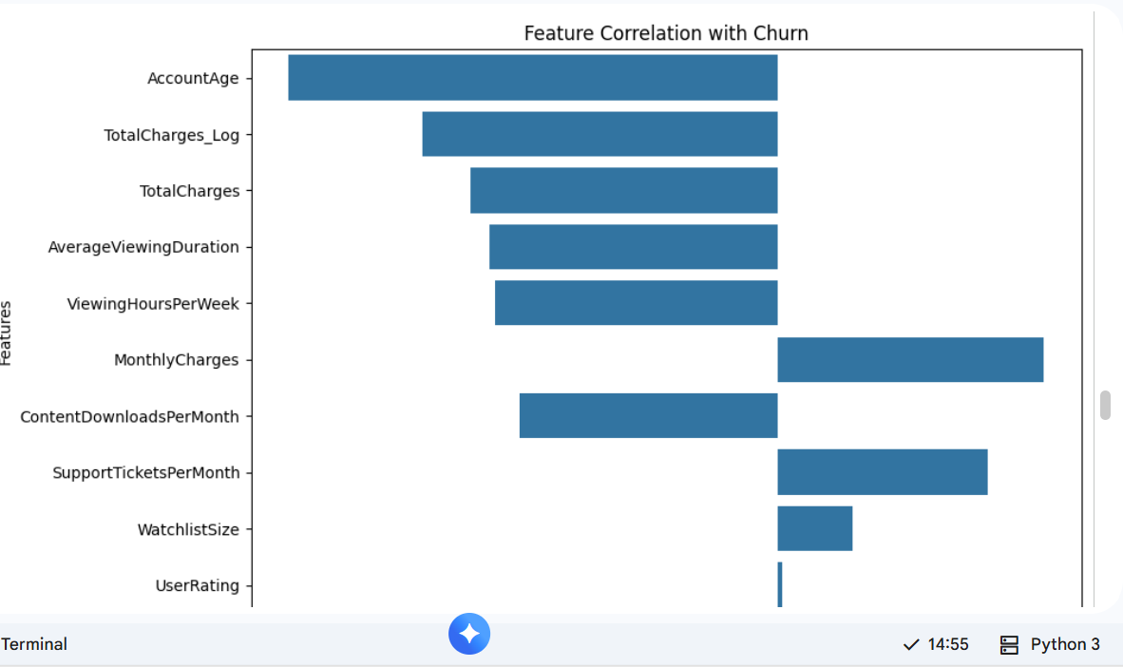

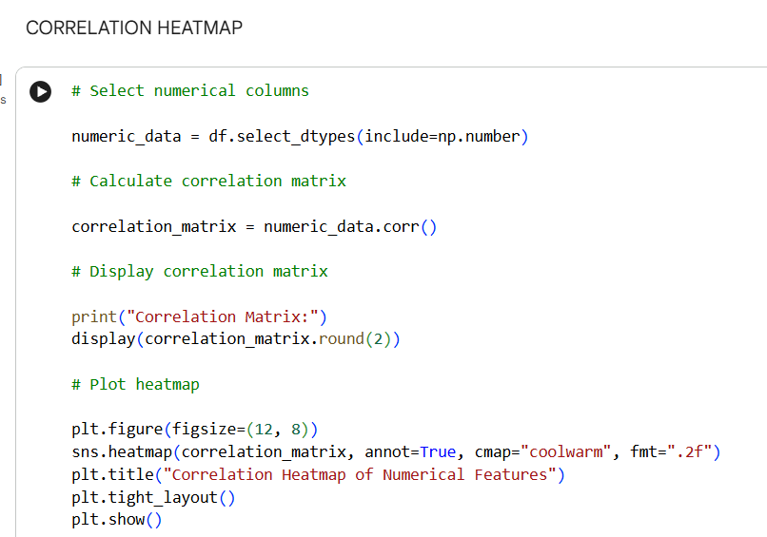

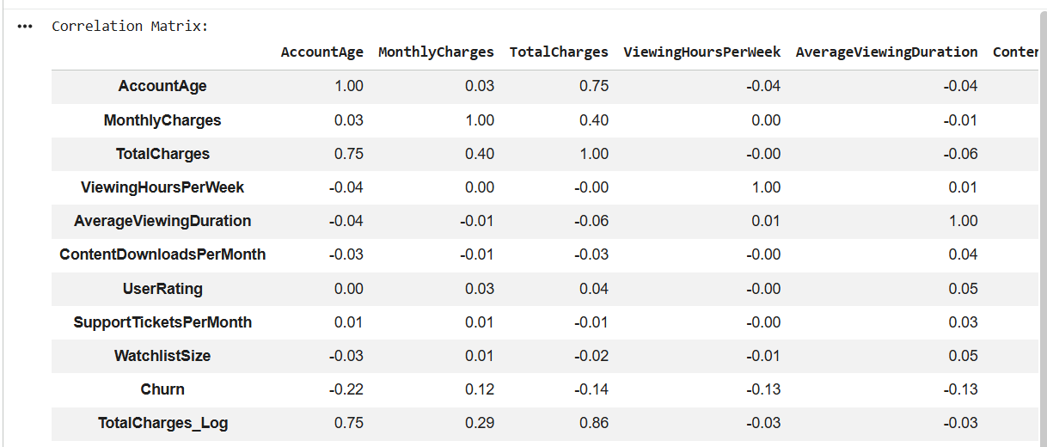

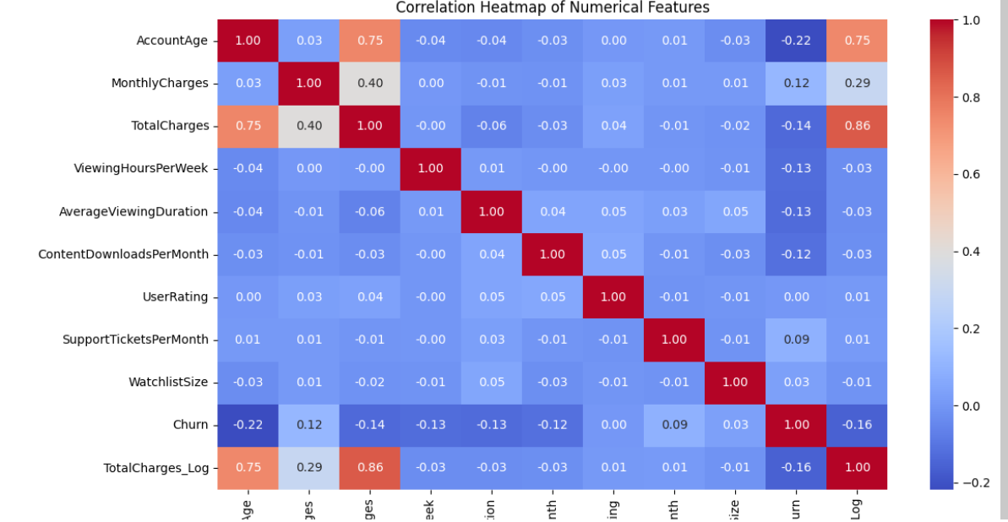

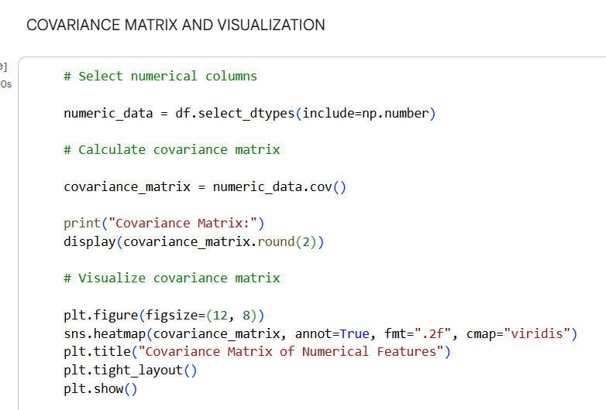

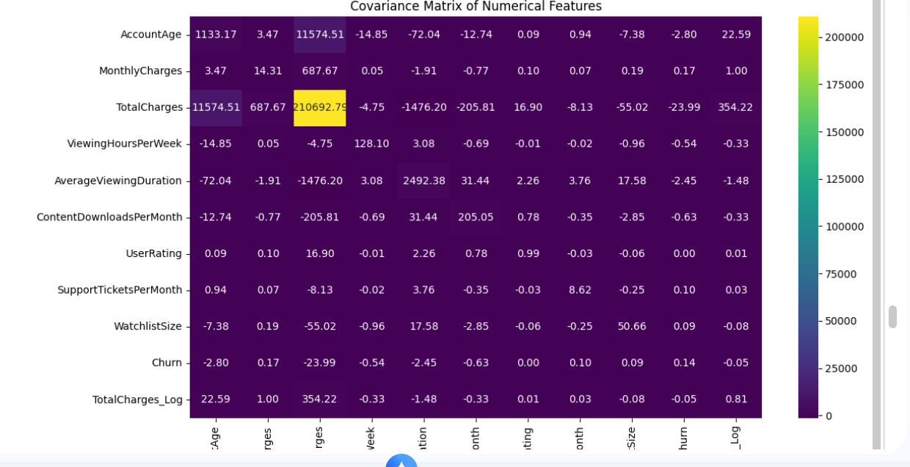

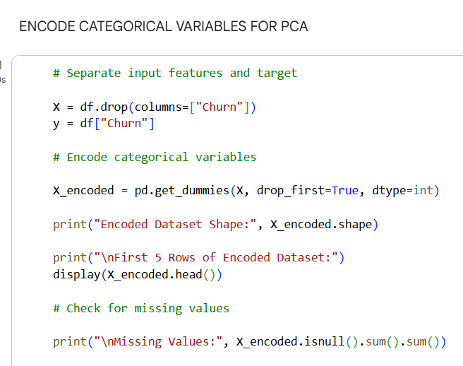

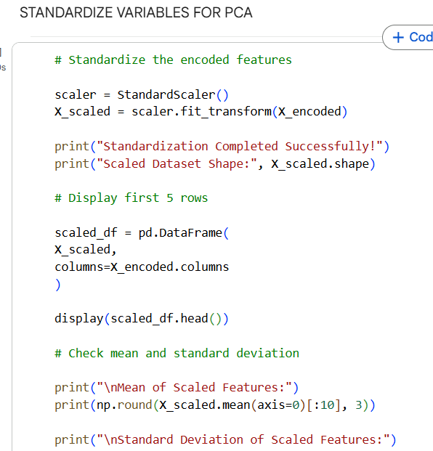

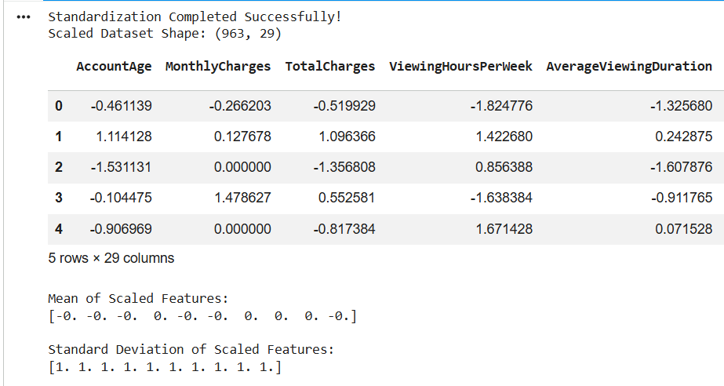

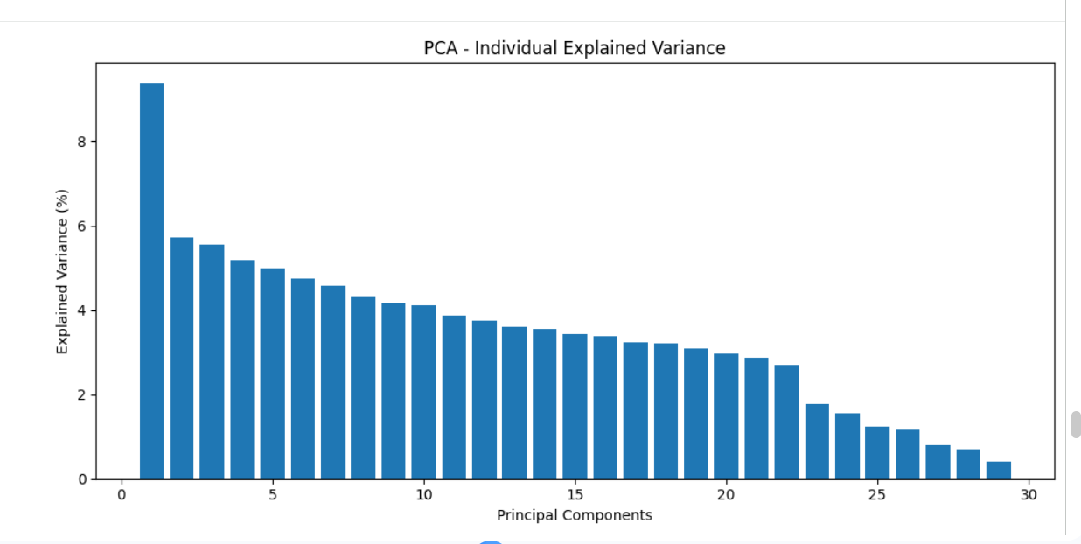
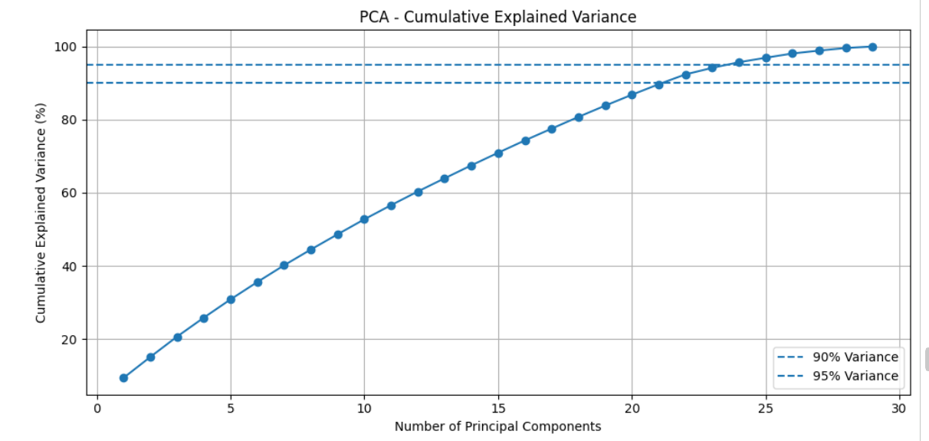
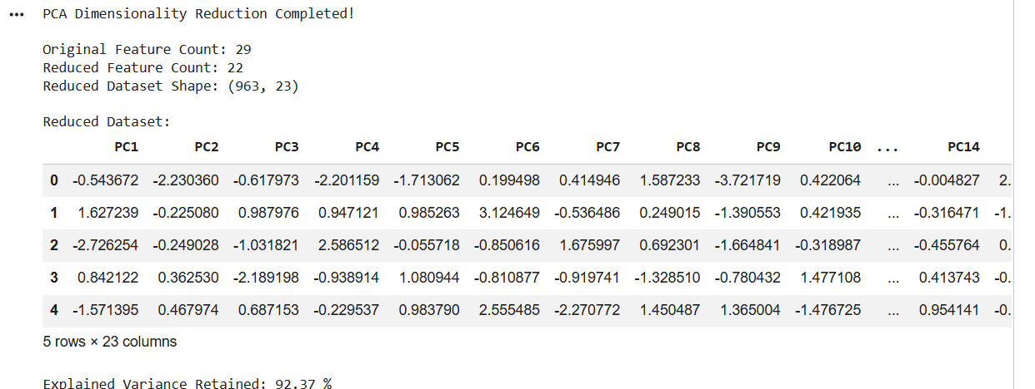
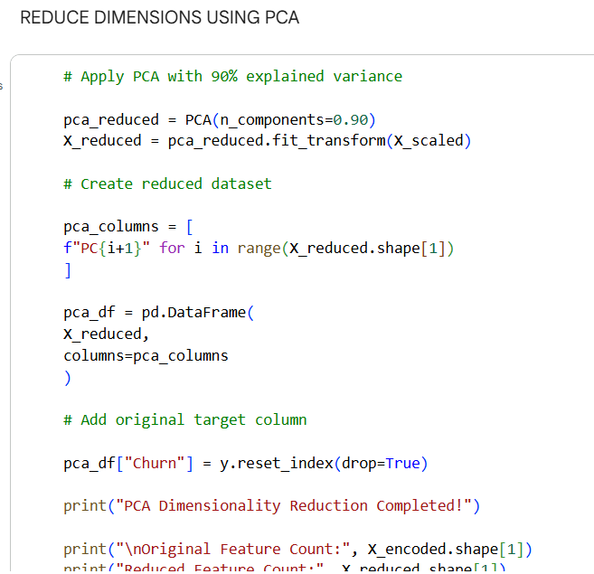

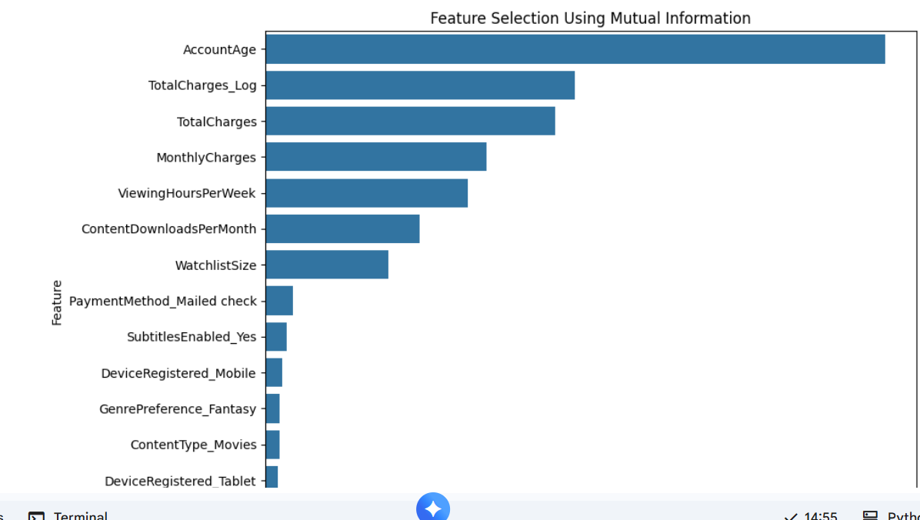

INTERPRETATION:

- First, the dataset was prepared by removing unnecessary columns and extracting useful time- based features such as hour, day, and month from the transaction timestamp. This helped in capturing important temporal patterns in the data.

- Next, only numerical features were selected for dimensionality reduction, and the target variable (is_fraud) was separated. Feature selection was performed using the SelectKBest method, which identified the most important features based on statistical significance. This reduced the number of features while retaining the most relevant information.

- After selecting the important features, standard scaling was applied to ensure that all features were on a similar scale. This step is important because dimensionality reduction techniques like PCA are sensitive to differences in feature magnitude.

- Principal Component Analysis (PCA) was then applied to transform the selected features into a smaller set of components. These components capture the maximum variance in the data, allowing the dataset to be represented in fewer dimensions while preserving important patterns. • Various visualizations such as scatter plots, density plots, and explained variance graphs were used to analyze the transformed data. These plots helped in understanding how well the data is distributed in reduced dimensions and how much information is retained by the principal components.

TEAM CONTRIBUTION:
TEAM MEMBERS | CONTRIBUTION
GOWTHAM S | Performed feature selection by identifying important features and removing irrelevant or redundant variables
HARIHARAN B | Implemented PCA and generated visualizations to analyze variance and reduced feature space and reviewed dimensionality reduction results
NIZANTH B C | Analyzed explained variance ratio and determined the optimal number of PC

WEEK 8:
DASHBOARD CONSTRUCTION

OBJECTIVE:
To construct an interactive dashboard using Power BI by integrating multiple visualizations into a cohesive narrative, enabling effective data storytelling, improved user interaction and clear interpretation of insights for better decision making.
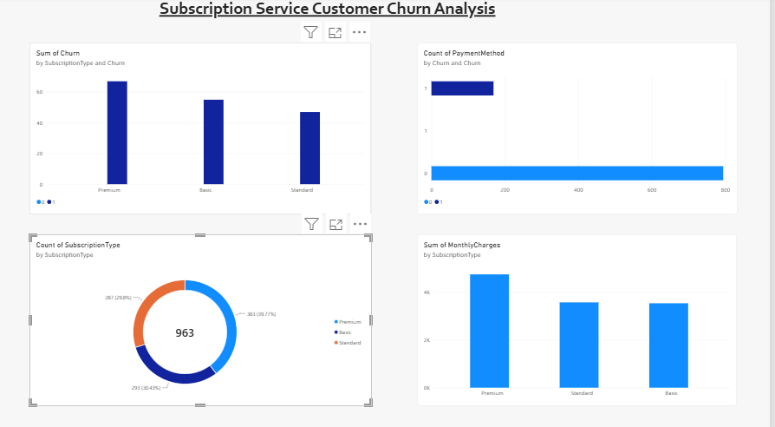
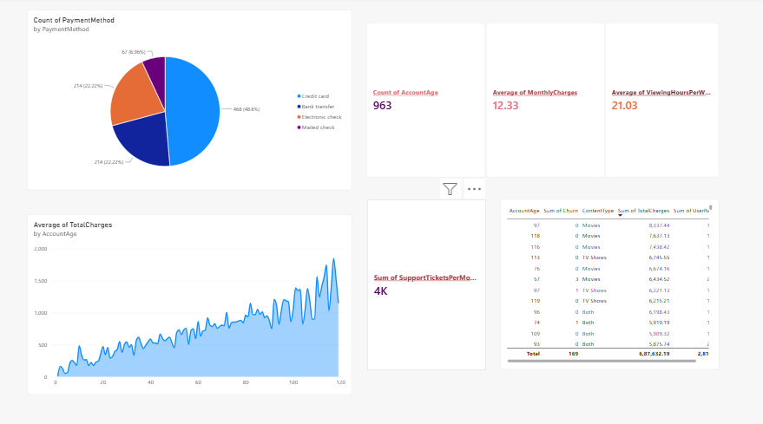
INTERPRETATION:

- The dashboard provides a comprehensive overview of credit card fraud transactions, analyzing over 555,719 transactions from Jan-Dec 2020.
- The total number of fraudulent transactions is 2.145K, with a fraud rate of 38.6%, indicating a significant presence of fraud in the dataset.
- The total fraud amount is approximately 1.133 million, showing that fraudulent activities involve a considerable financial impact.
- Category-wise analysis shows that shopping and grocery-related transactions have the highest number of fraud cases, indicating these categories are more vulnerable.
- The monthly trend of fraud transactions shows fluctuations over time, with certain months experiencing higher fraud activity, suggesting seasonal or behavioral patterns.
- Transactions categorized by risk level indicate that a larger portion falls under high-risk transactions, highlighting potential areas of concern.
- The top fraudulent merchants analysis identifies specific categories like travel, entertainment, and shopping where fraud frequently occurs.
- The geographical (state-wise) visualization shows that fraud is spread across multiple regions, with some areas having higher concentrations.
- Overall, the dashboard effectively highlights fraud patterns based on category, time, risk level, and
- location, helping in better understanding and detection of fraudulent activities.

TEAM CONTRIBUTION:

TEAM MEMBER | CONTRIBUTION
GOWTHAM S | Assisted in organizing the final dataset and supported report preparation related to dashboard insights and findings.
HARIHARAN B | Designed dashboard visuals and contributed to structuring the layout for clear data storytelling and interpretation.
NIZANTH B C | Developed the Power BI dashboard by integrating multiple visualizations and implementing filters for user interaction

